Business: The Company File
Belgium bans Coca-Cola
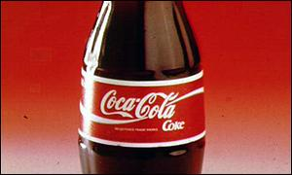
Coca-Cola is still trying to pin down the cause of the problem
The Belgian Government has banned the sale of all Coca-Cola drinks following more reported cases of poisoning across the country.
The cause of the poisoning has not been identified but the firm says some of its products may have caused head or stomach pains, although no serious health risks are thought to be involved.

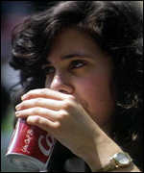
Some 15m cans and bottles are being withdrawn
Belgian Health Minister, Luc Van den Bossche, urged Belgians not to drink Coca-Cola or other Coca-Cola brands such as Fanta, Sprite, Aquarius and Bonaqua.
Some 15 million cans and bottles of soft drink are being withdrawn from sale.
On Monday, 40 students were hospitalized with symptoms of poisoning in Lochristi in west Belgium.
The health minister said that doctors across Belgium had also reported cases of poisoning after people drank Coca-Cola products.
He said the nature and cause of the poisoning were under investigation.
Latest food scare

The BBC's Jonathan Beale: More than 15 million cans recalled
The sales ban on Coca-Cola comes as Belgium is still reeling from revelations that cancer-causing dioxin had entered the food chain through animal feed in recent months.
That led the government to ban sales of chicken, pork, beef, eggs and meat products.
Mr Van den Bossche told Belgian radio that the Coca-Cola ban would "remain in effect until it becomes clear what the origin and nature of the contamination are".
Last week, the Belgian branch of Coca-Cola announced a recall of 2.5 million bottles of Coca-Cola after 31 schoolchildren in northern Belgium were hospitalised after drinking the beverage.
The company said some bottles had a quality defect, which can lead to symptoms such as headaches, nausea and stomach cramps.
The soft-drink company sent researchers to the school at Bornem where students fell ill last week.
Coca-Cola has been active in Belgium for 70 years. It has large bottling operations in Antwerp and Ghent.

