Comparing Coca-Cola and Pepsi's Business Models (KO, PEP)

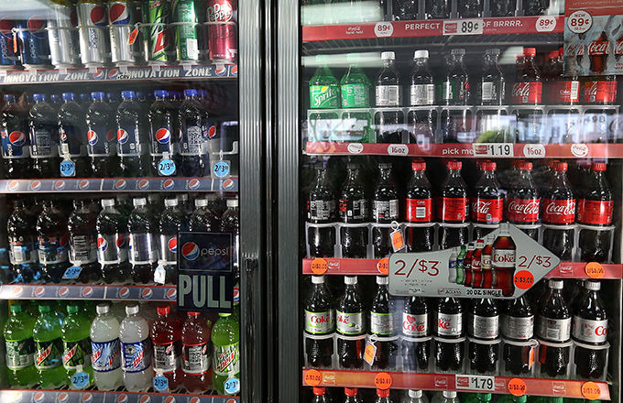
Coca-Cola Co. (KO) and PepsiCo, Inc. (PEP) are very similar businesses in terms of industry, ideal consumers and flagship products. Both Coca-Cola and PepsiCo are global leaders in the beverage industry, offering consumers hundreds of beverage brands. In addition, both companies offer ancillary products such as consumer packaged goods.
On the surface, Coca-Cola and PepsiCo have very similar business models. As potential investors dig deeper, however, they find key differences and key similarities between the two business models that make the companies what they are as of 2015. The following are four key comparisons between Coca-Cola and PepsiCo's business model that make the two companies fierce competitors and unique businesses.

1. Diversified Business Model
PepsiCo is a company known for a highly diversified product portfolio, both within the beverage industry and in other industries such as the consumer packaged goods industry. In contrast, Coca-Cola only focuses on a diversified product portfolio within the beverage industry and has few products outside of that industry. This means PepsiCo's products in the snack food category account for more than 50% of its business revenue, while a majority of Coca-Cola's revenue comes directly from the 100-plus beverage products it owns.
In a scenario where the beverage industry declines in overall revenue, PepsiCo is positioned to take advantage of the situation, while Coca-Cola may falter. However, Coca-Cola has more focus within the beverage industry, allowing it to make key investments and communicate key messaging with consumers.

2. Complementary Products
With PepsiCo's diversified business model, the company has been able to acquire or create complementary products in both the food industry and the beverage industry. According to Information Resources, Inc., a market research company, 54% of U.S. consumers polled reported that when they buy a salty snack, they also buy a beverage in the same checkout basket.
Even though Coca-Cola may have an advantage with a more focused business model, PepsiCo created a scenario where one product the company owns may induce a consumer to purchase a second product the company also owns. In contrast, Coca-Cola has made efforts to dominate the beverage industry almost exclusively and shied away from the cross-promotion of multiple products in multiple industries.

3. Pushing Into New Markets
Both Coca-Cola and PepsiCo are so large, they face the issue of market saturation. There are not many new or emerging markets that remain untapped for either company. However, both companies have made a push into the energy drink category. This push highlights the fact that sales volume for Diet Pepsi and Diet Coke has declined steadily over the past 10 years, according to Time Magazine. What is interesting to note is that Time Magazine also reports that the energy drink segment of the beverage industry has captured year-over-year growth over the past 10 years. Keeping with the theme of diversification and product complements, Coca-Cola bought a large stake in Monster Energy in 2014, and PepsiCo decided to start its own energy drink: Mountain Dew Kickstart.

4. Efficient Business Operations
With both companies facing market saturation, Coca-Cola and PepsiCo have made strong commitments to more efficient operations in 2015. This allows both companies to take advantage of the few new and emerging markets left. Since every large market has been fully tapped by the beverage industry, the remaining smaller markets require efficient operations to turn a profit and make a lucrative investment, since the sales volume felt in countries such as the U.S. is not there. These more efficient operations help both companies increase the price per share given it should result in higher earnings per share, or EPS, even if sales remain flat.

