Every organization wants to avoid a costly, lengthy, and resource-intensive lawsuit for trademark infringement. While definitions can vary globally and within the U.S., organizations can be taken to court if there's a likelihood of confusion, especially when combined with other similarities around the goods or services, purchasing channels, or other factors. Unique factors can vary significantly, but experts estimate the average cost of a trademark lawsuit can be between $120,000 to $750,000 in addition to years of valuable time.

The sheer output of resources necessary to defend your brand or organization in litigation can be draining to companies of any size. While large organizations aren't necessarily the most susceptible to trademark infringement litigation, they're often the most likely to suffer a loss of public image when their cases hit the news.

. China: 3M v. 3N
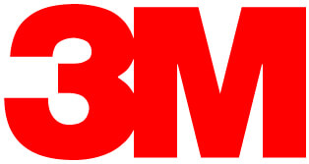
A lawsuit by The 3M company against Changzhou Huawei Advanced Material Co Ltd for the use of 3N resulted in a win for 3M and "significant damages" for 3M. It was ultimately ruled that, despite some dissimilarities in products and pricing, the notoriety of the 3M mark and the fact that 3N had managed to acquire clients and market share by use of the similar mark, constituted infringement.
One analysis notes this can be indicative of trademark case results in Chinese courts, where these matters are taken "seriously." While this particular case was complex and confusing, 3N definitely veered into dangerous zones by emulating the trademarked named of such a well-known brand. It was ultimately held that the "3M" trademark had a high distinctiveness and reputation.

Verdict in Favor of 3M.

South Korea: Louis Vuitton v. Louis Vuiton Dak
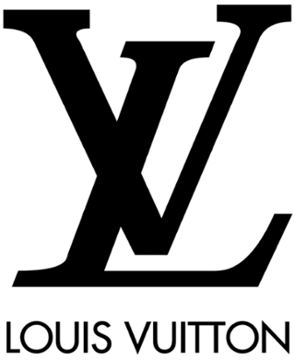
In one of the more shocking examples of international trademark infringement, a South Korean fried chicken restaurant recently lost a trademark battle with designer Louis Vuitton. The court ruled in the designer's favor after determining that the restaurant's name of Louis Vuiton Dak was too similar to Louis Vuitton. In addition to the name infringement, the restaurant's logo and packaging closely mirrored the designer's iconic imagery.
The restaurant was ultimately hit with another 14.5 million fine for non-compliance, after changing their name immediately after the first ruling to LOUISVUI TONDAK. Many brands can avoid similarly expensive legal battles by avoiding mirroring their brand closely after another, even if the products and purchase channels have nothing in common.

Verdict in Favor of Louis Vuitton.

5. US: Adidas v. Forever21
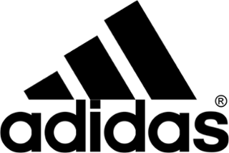
Adidas very recently filed a lawsuit against clothing retailer Forever21 alleging that the retailer's products, which contain a "three stripe" design, constitute "counterfeit products." Adidas reports they have "invested millions" to build and protect the three-stripe design as a trademark component of their brand and own "numerous" patents.
While representatives for Adidas and Forever21 have not released further comments in regards to the lawsuit since initial statements, it remains to be seen how the courts will respond to the lawsuit. Given the similarity of Forever21 and Adidas' products and distribution channels, Forever21 may have been able to avoid this lawsuit by evaluating their recent designs against Adidas' products and trademarks.

Verdict Pending.

US: Starbucks v. Freddocino
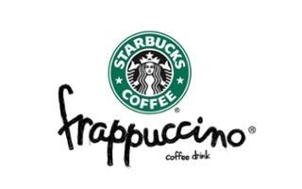
In January 2016, Starbucks filed a lawsuit against the parent company of New York's Coffee Culture Cafe for launching a drink called the "Freddocino" The lawsuit's documents allege that not only does the drink appear similar to the Frappucino, the structure of the name contains enough similarities to cause "confusion in the marketplace" and diminish "Starbuck's brand equity."
Starbucks does own the trademark for the term Frappucino, and additionally alleged that Coffee Culture has created deceptive packaging to make it appear the term "Freddocino" is trademarked when it is not. While Coffee Culture Cafe has changed the name of the drink to a "Freddo," Starbucks is proceeding with the lawsuit. Coffee Culture could have avoided the issue by avoiding infringement on a closely-guarded trademark, with an annual value of approximately $1.5 billion.
Verdict pending

Brown wins Da Vinci Code case

A high court judge today rejected claims that Dan Brown's bestselling novel The Da Vinci Code breached the copyright of an earlier book.
Michael Baigent and Richard Leigh had sued publishers Random House claiming that Mr Brown's book "appropriated the architecture" of their book, The Holy Blood And The Holy Grail, which was published in 1982 by the same publishing house.
The claimants said Mr Brown - whose book has made him the highest-paid author in history - had "hijacked" and "exploited" their book, which took them five years to create.
But in his ruling this afternoon at the high court in London following a three-week trial, Mr Justice Peter Smith said the claim for copyright infringement had "failed and is dismissed".
The claimants were ordered to pay 85% of Random House's legal costs, which are estimated at nearly £1.3m, with an interim payment of £350,000 to be made by May 5.
The judge said that a comparison of the language in The Holy Blood And The Holy Grail and The Da Vinvi Code did show some limited copying of the text.
"However this is not alleged to be a copyright infringement ... so does not assist the claimants. Such copying cannot amount to substantial copying of the text of The Holy Blood And The Holy Grail and the claimants have never said it does," Mr Justice Smith said.
If successful, the copyright case could have had huge ramifications for the publishing industry. Random House said the ruling "ensures that novelists remain free to draw in ideas and historical research".
The reclusive millionaire author from the US, who drew crowds of fans to the court when he gave evidence for three days last month, said he was "pleased" with the ruling personally and also "as a novelist".
The writer, who was not in court today, said in a statement: "Today's verdict shows that this claim was utterly without merit. I'm still astonished that these two authors chose to file their suit at all."
While giving evidence, Mr Brown had told the court that the claims were "completely fanciful". He had read Mr Baigent and Mr Leigh's book - which they wrote with a third author who was not involved in the legal action - but he insisted it was just one of many he had used as part of his research with the help of his wife, Blythe.
The Holy Blood And The Holy Grail, which was a smaller bestseller, sets out a theory that Jesus and Mary Magdalene married and had a child. It claims the bloodline continues to this day, with a secret society protecting their heirs against conspiracies enacted by the Catholic church. It is similar to the theme explored in Mr Brown's novel, which has sold more than 40m copies worldwide since its publication in 2003.
In his ruling, the judge said the claimants' version of their book's central themes had been designed retrospectively to help their case. There was no "architecture" or "structure" to be found in The Holy Blood And The Holy Grail as contended by Mr Baigent and Mr Leigh.
"Even if the central themes were copied, they are too general or of too low a level of abstraction to be capable of protection by copyright law," the judge said.
"Accordingly there is no copyright infringement either by textual copying or non textual copying of a substantial part of The Holy Blood And The Holy Grail by means of copying the central themes."
In his statement, Mr Brown said a "novelist must be free to draw appropriately from historical works without fear that he'll be sued and forced to stand in a courtroom facing a series of allegations that call into question his very integrity as a person".
He said books were an "important part of our culture, and this is a good day both for those who write and for those who enjoy reading".
Gail Rebuck, chairman and chief executive of The Random House Group Limited, said they were pleased that "justice - and common sense - have prevailed".
She went on: "It is highly unusual and very sad that these authors chose to sue their publishers, especially after 20 successful years ... We never believed it should have come to court - and frequently tried to explain why to the claimants."
Sales of both books rose during the trial, which has spawned headlines around the world. A film version of the novel is due to be released on May 19, starring Tom Hanks and Audrey Tautou.
Referring to the film, the judge said there had been cynical suggestions that the trial was a publicity campaign for the movie with all of the authors acting in cahoots.
He said: "If it was such a collaborative exercise, Mr Baigent and Mr Brown both went through an extensive ordeal in cross examination which they are likely to remember for some time."
There was also exciting news for Mr Brown's British fans: he plans to return to the UK, and said he can now fully focus on his next book.
"I found the high court building to be a magnificent example of neo-Gothic architecture; I look forward to returning soon to view it from a vantage point other than the witness stand," Mr Brown said. "After devoting so much time and energy to this case, I'm eager to get back to writing my new novel."

